**Assignment 9**

1. **What are the different margins options and do we adjust the margins of**

**the excel worksheet?**

* Normal
* Wide
* Narrow

Yes, As per need we can adjust margins

1. **Set a background for your table created.**

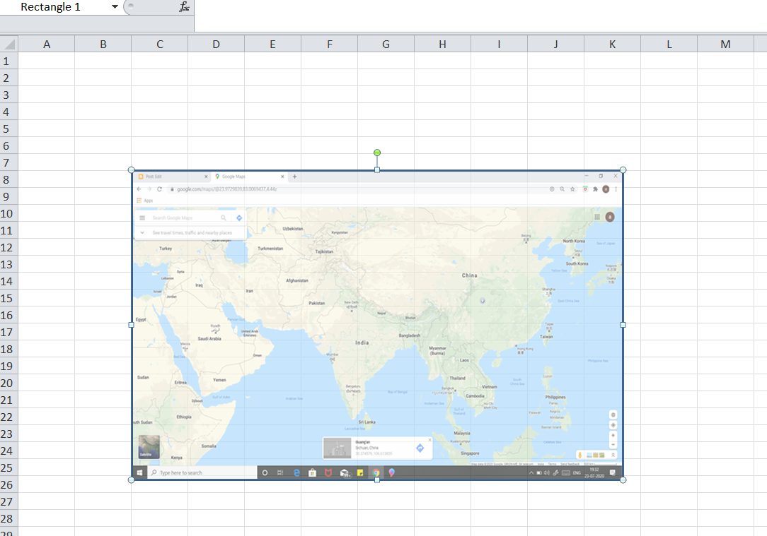

1. **What is freeze panes and why do we use freeze panes? Give examples.**

* To freeze any column or row so that it will continuously displayed on the excel screen.
* We use it when we have to enter data for reference we freeze plane for reference purpose.
* Eg. We freeze 1st row of table so that while entering data we should know in which column we are entering data

1. **What are the different features available within the Freeze Panes command?**

* **Freeze Panes**
* **Freeze Top Row**
* **Freeze First Column**

1. **Explain what the different sheet options present in excel are and what they do?**

* Insert : We can insert new sheet
* Delete : To delete sheet
* Rename : To give specific name
* Move : To move from one workbook to another
* Hide : To hide
* Tab color : To Tab color